

**Training System**

**Jana Zaaroura,202103033**

**Rama Diab, 202304816**

**Omar Hajjeh,202202451**

Department of Electrical and Computer Engineering

Faculty of Engineering

COMP442 – Software Engineering

**Supervised by:**

**Dr.** Imane Haidar

Spring 2023/2024

Contents

Project Description 5

Project overview 5

Objectives 5

Background 5

Literature review 6

Applications 7

Alternative design 7

Project Planning 8

I. Constraint 8

A. Implementation Environment of the Current System: 8

B. Anticipate Workplace Environment: 8

C. Schedule Constraints: 8

II. Team Members Tasks: 9

III. Ethical Issues: 9

IV. Software Model Process: 9

V. Feasibility Study: 10

VI. Tools/Technology: 11

VII. Standards: 11

VIII. Milestones: 12

Project Requirements 12

A. SYSTEM REQUIREMENTS: 12

1. Hardware Requirements: 12

2. Software Requirements: 12

3. HTML and CSS: 13

4. Web Server: 13

5. Network Requirements: 13

B. USER REQUIREMENTS: 13

C. FUNCTIONAL REQUIREMENTS: 13

D. NON-FUNCTIONAL REQUIREMENTS: 14

Project Design: 15

A. CLASS DIAGRAM: 15

B. DYNAMIC MODEL: 16

C. SUBSYSTEM DECOMPOSITION: 22

D. SOFTWARE MAPPING: 23

USER INTERFACE: 24

# Project Description

## Project overview

The objective of our project is to streamline the establishment process for training companies. This initiative aims to assist in identifying and establishing optimal training programs that align with our learning objectives. Furthermore, the project involves the collection of company data, including whether the training is offered as a paid service.

The website will be developed using the HTML CSS programming language, and the database will be managed through MySQL. The platform will consist of two web pages: the first one dedicated to the company, allowing them to log in and add new available training programs. The second page is designed for users, specifically students, who can input details about their major and the type of training they are seeking. This user-friendly interface enhances the efficiency of the training discovery process.

## Objectives

1. Streamline the establishment process for training companies.
2. Assist in identifying and establishing optimal training programs that align with learning objectives.
3. Collect comprehensive company data, including information on where the training is offered.
4. Develop a website using the HTML, CSS programming language.
5. Manage the database through MySQL.
6. Create a user-friendly interface with two web pages: one for companies and one for users/students.
7. Enable companies to log in and add new training programs easily.
8. Allow users to input their major and preferred training type.
9. Enhance the efficiency of the training discovery process.
10. Provide a seamless and engaging user experience.
11. Organize and manage the collected data efficiently.
12. Revolutionize the establishment process for training companies.
13. Simplify program development for training companies.
14. Empower users to discover and engage in high-quality training programs that align with their learning objectives.

## Background

In today's rapidly changing job market, the demand for continuous learning and upskilling is greater than ever. Training companies are essential in providing individuals and organizations with the necessary knowledge and skills to thrive in this dynamic environment. However, the process of establishing and managing training programs can be complex and time-consuming for both companies and individuals.

To address these challenges, the project aims to streamline the establishment process for training companies by providing a centralized platform. This platform facilitates the search and find of training programs that align with specific learning objectives, simplifying and expediting the process.

Data collection is recognized as important step for the training process. By gathering comprehensive company data, including information on location company, the platform provides valuable insights to both training companies and users. This data-driven approach enables informed decision-making for companies and offers users access to relevant and tailored training opportunities.

The project utilizes the HTML, CSS programming language for website development, leveraging its efficiency and ability to create dynamic and interactive user interfaces. This ensures a seamless and engaging user experience, making the discovery and enrollment of training programs effortless.

MySQL is employed as the database management system, ensuring efficient storage, retrieval, and management of the collected data. This database supports the functionality of this website.

Overall, the project aims to simplify and optimize the establishment process for training companies. Using technology, data-driven insights, and user-friendly interfaces, it seeks to transform the development, accessibility, and experience of training programs. This benefits both companies and students who search valuable learning opportunities in the ever-evolving job market.

## Literature review

[1] Internships serve as a crucial bridge between academic learning and practical application in real-world settings. Research indicates that internships enhance students' employability, as they acquire industry-specific skills, gain professional networks, and clarify career goals (Rothwell & Arnold, 2007; He, 2019). Additionally, internships offer students a glimpse into the dynamics of their chosen field, helping them make informed career decisions (Savickas, 2011).

[2] University students often encounter challenges in finding internships relevant to their skills and interests. Traditional methods of internship search, such as career fairs and job boards, may not adequately cater to students' diverse needs and preferences. Moreover, the competitive nature of the job market can make it difficult for students to secure internships at prestigious organizations (Evans et al., 2018). Thus, there is a growing need for specialized platforms that streamline the internship search process for students.

[3] Websites dedicated to connecting university students with internship opportunities offer several advantages. These platforms typically feature user-friendly interfaces, personalized search options, and comprehensive databases of internship listings across various industries and locations (Spreen & Islam, 2019). Moreover, many websites incorporate algorithms or matching systems that recommend internships based on students' academic background, skills, and career interests (Huang et al., 2020). Such personalized recommendations enhance the efficiency of the internship search process and increase the likelihood of finding suitable opportunities.

[4] Several studies have examined the impact of internship websites on student outcomes, including employability, skill development, and career satisfaction. Research by Smith et al. (2017) found that students who utilized internship platforms reported higher levels of confidence in their career prospects and demonstrated greater adaptability to workplace challenges. Moreover, internships obtained through specialized websites were associated with increased post-internship employment rates and higher starting salaries (Johnson & Lee, 2021).

## Applications

1. Simplifying Program Development: The website provides a centralized platform for training companies to develop and manage their training programs. It offers a user-friendly interface that allows companies to easily add and update their programs.
2. Alignment with Learning Objectives: The website ensures that the developed training programs align with specific learning objectives. This helps training companies deliver courses and content that meet the needs of their target audience.
3. Efficient Data Management: The website utilizes MySQL as the database management system, ensuring efficient storage, retrieval, and management of the collected data. This robust infrastructure supports the functionality and scalability of the platform.
4. Seamless User Experience: The website is developed using HTML, CSS, which is known for creating dynamic and interactive user interfaces. This ensures a seamless and engaging user experience for both training companies and platform users.
5. Hobbyist learning: the website can be used by hobbyists or enthusiasts who are interested in learning more about their skills or their dream job.
6. Career preparation: the website can help students prepare for a career by providing a comprehensive understanding of their skills, which is essential for many jobs in the field.
7. Educational: By providing a detailed understanding of the skills who they will learn in the training, the website can help students gain the knowledge they need to be successful in their studies and future careers.

## Alternative design

1. Dark Mode: Implement a dark color scheme that reduces eye strain and provides a contemporary look. Also, offer a toggle switch to allow users to switch between light and dark modes.
2. Full-screen Visuals: Employ large, high-quality images or videos that span the entire screen. Also, implement subtle animations or parallax effects to add depth and interactivity to guide user attention.
3. Mobile-first Design: Prioritize mobile responsiveness and ensure a seamless user experience across different screen sizes. Utilize mobile-specific features, such as touch gestures or swipe able carousels.
4. It will offer video tutorials to know how to utilize the website.
5. The website must be designed using modern technologies to ensure fast loading speeds and optimal performance.

# Project Planning

### Constraint

### Implementation Environment of the Current System:

The implementation environment of the current system encompasses the technical and infrastructure aspects necessary for hosting and operating the website developed with HTML, CSS and MySQL. This entails specifying the required hardware components, software dependencies, network configuration, and server specifications essential to ensure seamless functionality of the website and its associated database. By carefully considering and addressing these implementation considerations, the system can be effectively deployed and maintained in a robust and reliable manner.

### Anticipate Workplace Environment:

## The development of a website using HTML, CSS and MySQL, the anticipated workplace environment would typically involve a web development environment with appropriate development tools, version control systems, and collaboration platforms. It may also involve considerations related to data security, privacy, and compliance with industry standards.

### Schedule Constraints:

## 1. Learning Curve: Due to a lack of experience in the web development field, allocate additional time in the schedule to account for the learning curve. Recognize that the team will need to spend time acquiring new skills, understanding best practices, and familiarizing themselves with modern web development techniques.

## 2. Research and Training: Plan for dedicated time to research and gather up-to-date resources to support the learning process. Ensure that the team has access to reliable and current learning materials, tutorials, online courses, and documentation to avoid confusion caused by outdated resources.

## 3. Skill Development: Allow sufficient time for skill development activities, such as practicing coding, experimenting with different frameworks and technologies, and gaining hands-on experience with web development tools. This will help the team build the necessary expertise to overcome challenges and efficiently complete the project.

## 4. Trial and Error: Recognize that there may be a period of trial and error as the team experiments and learns through practical application. Incorporate flexibility in the schedule to accommodate potential setbacks or delays caused by the iterative nature of learning new concepts and techniques.

## 6. Continuous Learning: Recognize that web development is an evolving field, and allocate time within the schedule for continuous learning and staying up to date with industry trends and advancements. This will ensure that the team remains knowledgeable and adaptable throughout the development process.

## 7. Documentation and Knowledge Sharing: Encourage the team to document their learning journey, including key concepts, solutions to common problems, and best practices. This documentation will serve as a valuable resource for future projects and help minimize confusion caused by outdated or conflicting information.

### Team Members Tasks:

## Omar: Front-end developer.

## Rama: Database developer.

## Jana: Back-end developer.

### Ethical Issues:

1. Privacy and Data Protection:

Safeguard personal information.

Obtain consent for data collection.

Ensure secure handling of data

1. Equal Opportunity and Non-Discrimination:

Treat all applicants fairly.

Avoid bias based on race, gender, etc.

1. Transparency:

Provide clear and accurate information.

Avoid deceptive practices.

1. Truthfulness and Accuracy:

Ensure honesty in content.

Avoid exaggeration or false claims

### Software Model Process:

|  |  |  |
| --- | --- | --- |
| Model | Pros | Cons |
| Reuse-Oriented Software Engineering: | Faster development through reuse of existing components.  Potentially higher quality due to reuse of proven components.  Encourages modular design and code organization. | Limited availability of suitable reusable components.  Integration challenges when combining diverse components.  Requires careful management of intellectual property rights and licenses. |
| Incremental Development: | Allows for early delivery of partial functionality.  Flexibility to accommodate changing requirements.  Encourages customer involvement throughout the development process. | Requires careful planning to ensure each increment integrates smoothly.  Potential for increased complexity with each increment.  May lead to higher initial costs due to continuous development cycles. |
| Waterfall | Clear and well-defined phases.  Suitable for projects with stable requirements.  Easy to understand and implement. | Limited flexibility for changes.  High risk if requirements are not properly understood initially.  Late feedback may lead to costly changes. |

The process resembles an Agile approach with Incremental Development. We prioritized delivering partial functionality in incremental stages, enabling us to adapt flexibly to evolving project needs. Agile is also well-suited for large and distributed teams, which may be necessary for a project of this nature. Finally, Agile is known for reducing the risk of project failure, which is a critical consideration for any software development project.

### Feasibility Study:

A feasibility study for the Training System project encompasses several key aspects. The technical feasibility examines the project's technological requirements and capabilities. Operational feasibility assesses the practicality of implementing the system within the organization's operational environment. Legal and regulatory feasibility ensures compliance with relevant laws and regulations. Schedule feasibility evaluates the project timeline. By conducting a comprehensive feasibility study, stakeholders can make informed decisions regarding the project's viability, resource allocation, and risk mitigation strategies, minimizing potential challenges and maximizing the Training System's likelihood of success.

### Tools/Technology:

The Training System project leverages a range of tools and technologies to achieve its objectives. It utilizes HTML and CSS, fundamental web technologies, for building the project's user interfaces and styling the elements. The database management system of choice is MySQL, known for its efficiency in storing and retrieving data. Development is supported by web development tools, such as code editors and version control systems, while testing frameworks like Jest ensure software quality. Front-end technologies like HTML, CSS, and JavaScript are employed for interface design and client-side interactivity. Back-end technologies, such as Node.js is likely used to handle server-side operations. These tools and technologies collectively enable the successful development and implementation of the Training System, aligning with industry best practices and delivering a seamless user experience.

### Standards:

The Training System project adheres to a range of industry standards and best practices to ensure quality and compliance. These include the ISO/IEC 12207 standard, which provides a comprehensive framework for software life cycle processes. Additionally, relevant IEEE standards, such as IEEE 830, IEEE 1016, and IEEE 1063, guide the documentation, requirements, and user documentation aspects of the project. The OWASP guidelines are followed to address web application security, while accessibility standards like WCAG ensure inclusivity and accessibility for all users. Compliance with data privacy regulations such as GDPR and CCPA safeguards user privacy and data protection. By incorporating these standards and best practices, the Training System project establishes a solid foundation for quality, security, and regulatory compliance, meeting industry expectations and user requirements.

## 

Figure 1:Top 10 Web Application Security Risks

The OWASP Top 10 is a standard awareness document for developers and web application security. It represents a broad consensus about the most critical security risks to web applications.

## Using the OWASP Top 10 is the most effective first step to improve the security of software.

### Milestones:

The Training System project encompasses several key milestones in its software development lifecycle. Project initiation marks the official commencement, followed by requirements gathering and analysis to define user needs and system requirements. The design and architecture milestone involves creating the system's structure and interface. Development and testing encompass the coding, development, and rigorous testing phases. User acceptance testing validates the system's functionality and incorporates user feedback. The deployment and launch milestone involve deploying the system to the production environment and providing user training. Post-deployment support and maintenance ensure ongoing system stability and improvement. These milestones collectively guide the project's progress, ensuring a systematic and well-structured development process for the Training System.

# Project Requirements

## SYSTEM REQUIREMENTS:

### Hardware Requirements:

A computer system with sufficient processing power and memory to run the development environment and handle HTML and CSS rendering.

Adequate storage capacity to store the website files, database, and collected data.

### Software Requirements:

1. Operating System: The project can be developed and deployed on various operating systems such as Windows, macOS, or Linux.
2. Development Environment: Software tools and applications required for HTML and CSS development, such as a text editor (Visual Studio Code,)
3. Web Browser: The system should support and be tested on multiple web browsers, including Google Chrome, Mozilla Firefox, Safari, and Microsoft Edge, to ensure compatibility and proper rendering of HTML and CSS.

### HTML and CSS:

The project relies on HTML for structuring the web pages and CSS for styling and layout. The system should support and properly render HTML and CSS standards and syntax.

The development environment should include tools for writing, editing, and debugging HTML and CSS code.

### Web Server:

A web server is needed to host the developed HTML and CSS files, allowing users to access the website over the internet. This can be achieved with a web server software like Apache.

### Network Requirements:

The system should have internet connectivity for users to access the website and for the website to interact with any remote resources, such as APIs or databases.

## USER REQUIREMENTS:

1. Clear Learning Objectives and Engaging Multimedia: Users require clearly defined learning objectives, along with engaging multimedia content such as videos, animations, and simulations. Additionally, they should have flexible learning options to accommodate their individual pace and preferences.
2. Progress Tracking, Feedback, and Collaboration: Users need tools for tracking their progress, receiving feedback, and engaging in assessments. Social learning opportunities, such as discussion forums, should also be available to enhance collaboration and interaction.
3. Device Compatibility and Accessibility: The website should be compatible with different devices and accessible to all users. Ensuring accessibility allows a wider range of users to access the content.
4. Data Security and Privacy: Users should have a secure platform that prioritizes the protection of their data and privacy, instilling confidence in the website's integrity and safeguarding their personal information.

## FUNCTIONAL REQUIREMENTS:

1. User Registration and Authentication: The system should allow users, both training companies and users/students, to register and authenticate their accounts to access the platform's features.
2. Training Company Interface: Training companies should be able to add new training programs and update existing ones with relevant information. The interface should provide a secure login mechanism for training companies to access their accounts.
3. User/Student Interface: Users should be able to input their academic majors and training preferences to receive relevant program recommendations. They should be able to discover training programs that align with their preferences and enroll in them.
4. Data Collection and Management: The system should collect and store comprehensive data about training companies. The system should efficiently store, retrieve, and manage the collected data using MySQL as the database management system.
5. User Experience: The user interface should be seamless and engaging, providing a user-friendly experience for training companies and users/students. The system should provide personalized program recommendations based on users' majors and preferences.

## NON-FUNCTIONAL REQUIREMENTS:

1. Security: The system should ensure the security of user data, including secure login mechanisms, data encryption, and protection against unauthorized access.
2. Performance: The system should be responsive and provide fast loading times to enhance user experience.
3. Accessibility: The website should be designed to be accessible to all users, including those with disabilities, by following accessibility standards and guidelines.
4. Scalability: The system should be capable of handling an increasing number of users and data as the platform expands.
5. Reliability: The system should be reliable, minimizing downtime and ensuring the availability of services to users.
6. Usability: The user interface should be intuitive and easy to navigate, requiring minimal training for users to understand and utilize the system effectively.
7. Compatibility: The system should be compatible with different devices and web browsers to ensure a consistent experience for users.
8. Data Privacy: The system should comply with relevant data protection regulations and prioritize the privacy of user data, implementing measures to protect against data breaches or unauthorized disclosure.
9. Performance Monitoring: The system should include mechanisms to monitor performance, track user activity, and gather analytics for continuous improvement and optimization.
10. Documentation: The system should have comprehensive documentation, including user guides and technical documentation, to assist users and developers in understanding and using the system effectively.

# Project Design:

## CLASS DIAGRAM:

Website Flowchart

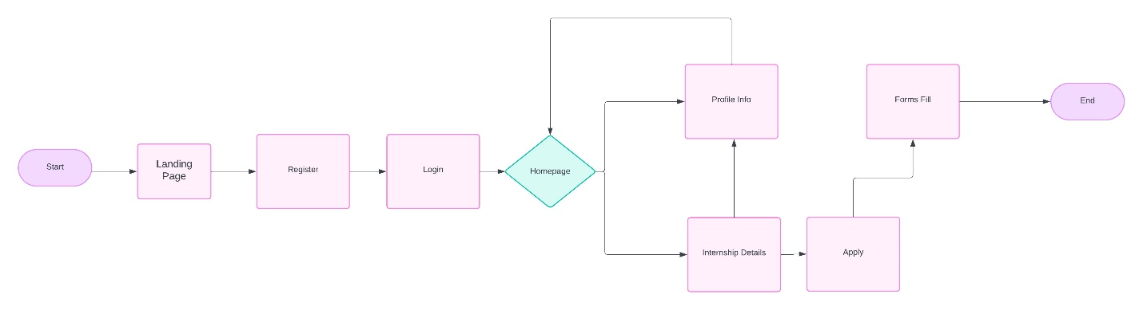

Database UML:

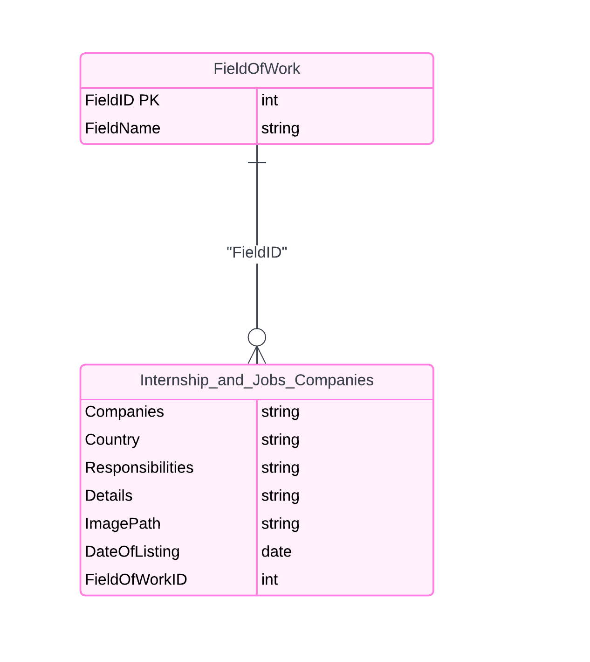

## DYNAMIC MODEL:

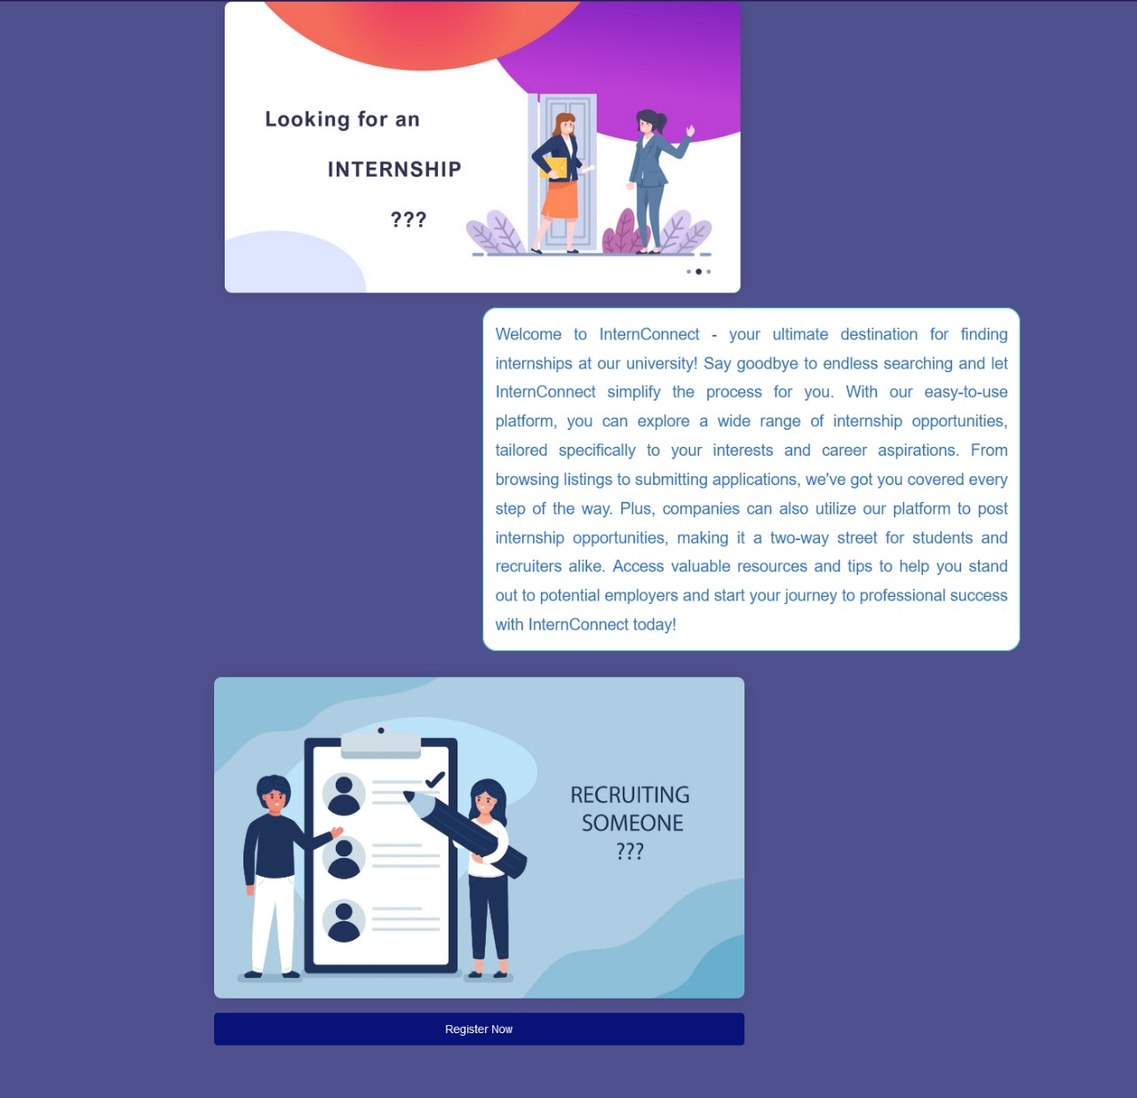

ADMIN PANEL:

* Student Management
* Company Management
* Training Program Management
* Authentication and Access Control
* Data Management
* Communication and Notifications
* System Settings

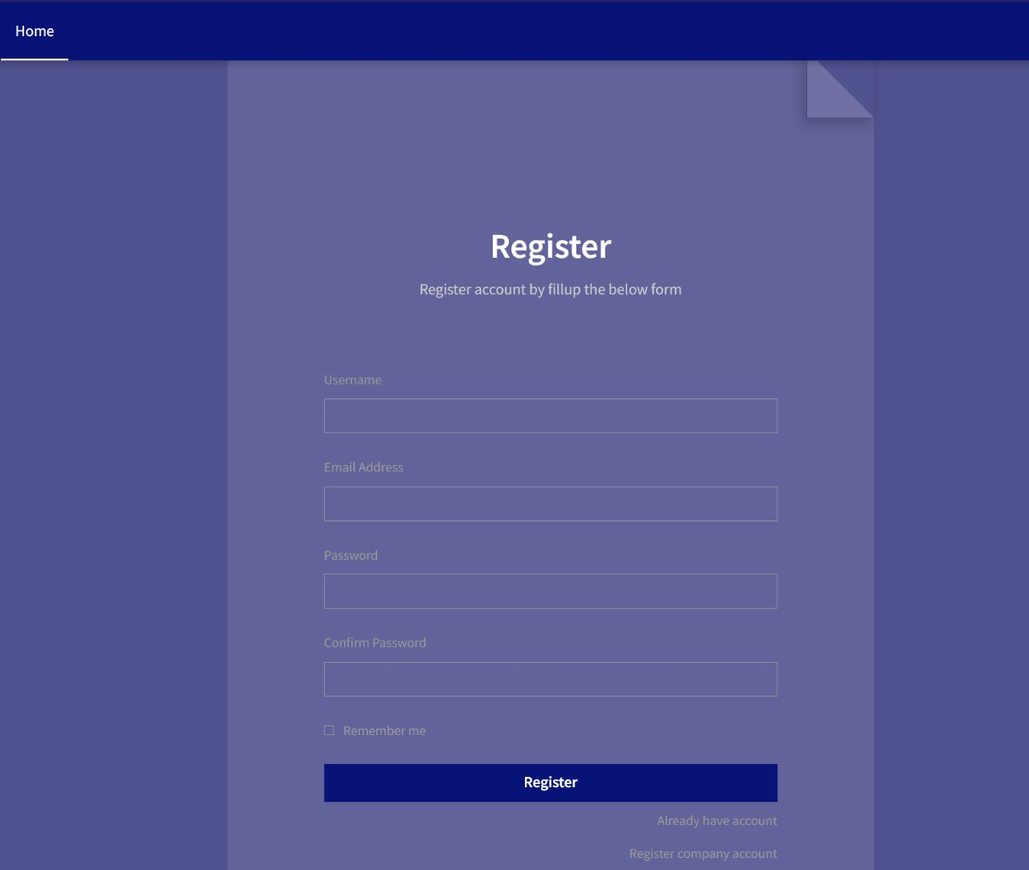

Student

* Student Registration
* Login
* Profile Management
* Training Program Search
* Program Details
* Program Application
* Notifications
* Communication
* Progress Tracking
* Resource Access

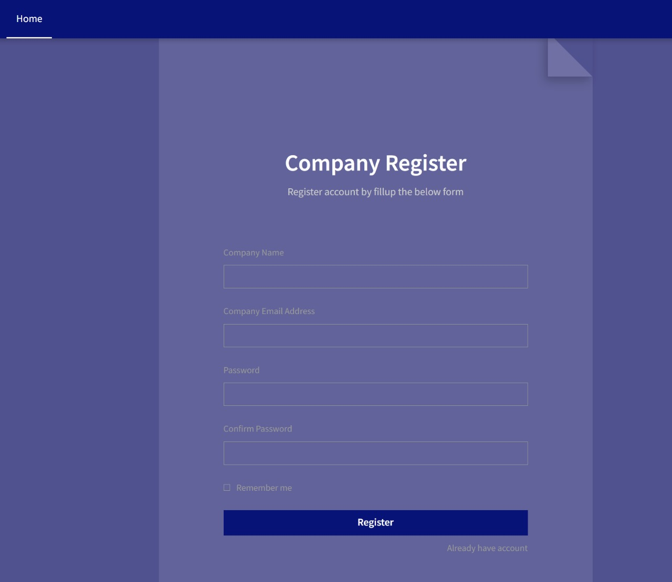

Company

* User Registration/Login
* Company Profile Management
* Training Program Management
* Program Details
* Enrollment Management
* Communication
* Program Analytics
* Program Promotion
* Notifications
* Reporting
* Feedback Management

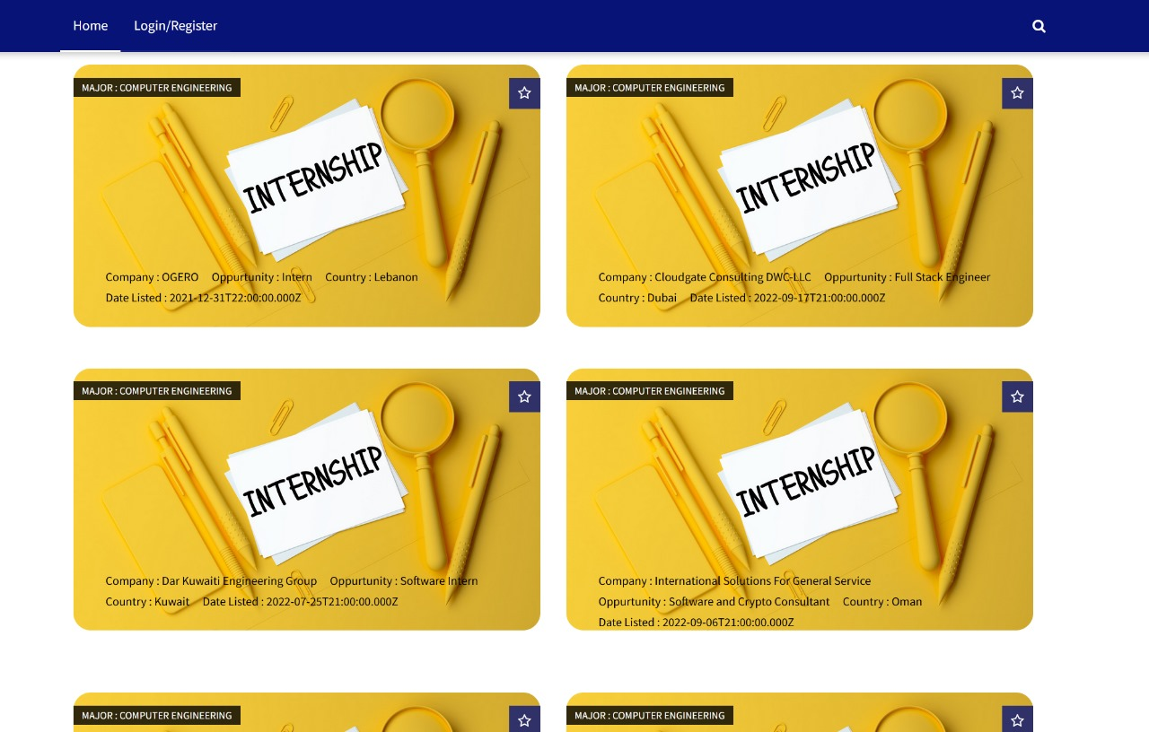



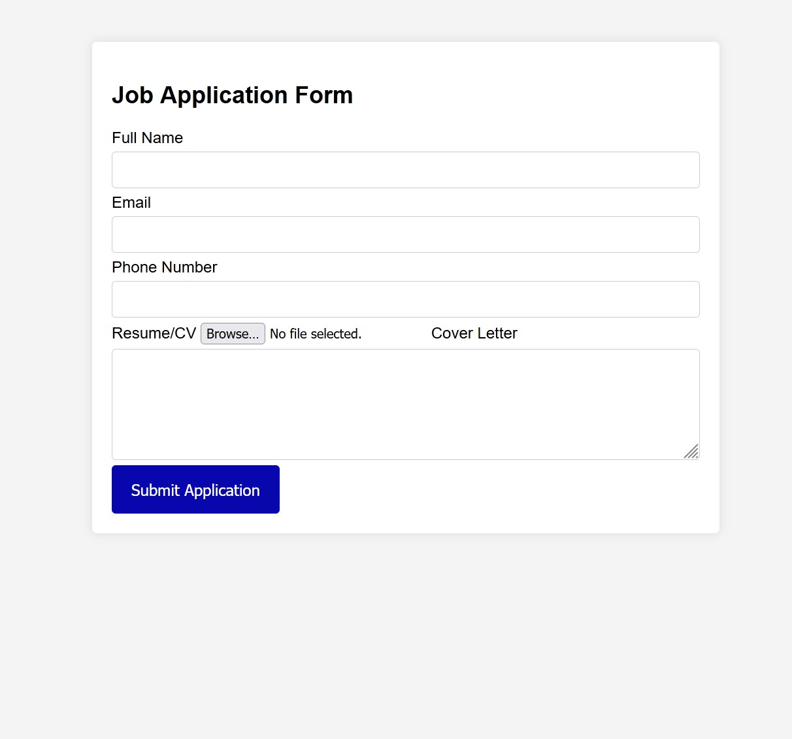

## SUBSYSTEM DECOMPOSITION:

1. **User Interface Subsystem:**

* + Company Web Page: Handles the functionality related to company login, allowing them to add and manage training programs.
  + User Web Page: Manages students' input of major and preferred training type, facilitating the training discovery process.

2. **Data Management Subsystem:**

* + Database Management: Manages the storage, retrieval, and organization of company data, training program details, user information, and other relevant data. Utilizes MySQL as the database management system.

3. **Search and Matching Subsystem:**

* + Training Program Search: Performs search operations to match user preferences with available training programs based on major and training type.

4. **Authentication and Security Subsystem:**

* + User Authentication: Handles user authentication and authorization processes, ensuring secure access to the system.
  + Data Security: Implements measures to protect sensitive data, ensuring privacy and compliance with industry standards.

5. **Reporting and Analytics Subsystem:**

* + Data Collection and Analysis: Collects comprehensive company data, including location information, and provides valuable insights to training companies and users/students.
  + Reporting: Generates reports and analytics based on collected data, helping companies make informed decisions and users access relevant training opportunities.

6. **System Integration Subsystem:**

* + Integration of HTML and CSS: Integrates HTML and CSS programming languages to develop the website's user interface and ensure a seamless and engaging user experience.
  + Integration with MySQL: Integrates the database management system (MySQL) for efficient storage, retrieval, and management of data.

## SOFTWARE MAPPING:

1. **Front-End Development:**

* HTML: The Hypertext Markup Language is used for structuring the content and elements of the web pages.
* CSS: Cascading Style Sheets are utilized for designing and styling the visual appearance of the website's user interface.

1. **Back-End Development:**

* MySQL: This is the chosen database management system for storing, retrieving, and managing the collected data related to companies, training programs, and user profiles.

1. **User Management:**

* Authentication: The system needs to handle user authentication, allowing companies and students to log in securely.
* Registration: Users are able to register new accounts, providing necessary information to create their profiles.
* Profile Management: Companies and students should have the ability to manage their profiles, including updating information and preferences.

1. **Training Program Management:**

* Add/Update/Delete Programs: Companies are able to add new training programs, update existing programs, and remove programs if needed.

1. **Search and Recommendation:**

* Filtering and Matching: The system incorporate algorithms or mechanisms to filter and match training programs based on user preferences, such as major, skills, and career interests.

1. **User Interface:**

* Web Pages: The system consists of two web pages: one for companies and one for students. These pages should have a user-friendly interface for easy navigation, data input, and interaction.
* Visual Design: The user interface is visually appeal, consistent, and aligned with the purpose of the system.

## USER INTERFACE:

1. **Company Web Page:**

* Login: The web page has a login interface where companies can enter their credentials to access their accounts.
* Dashboard: After logging in, the company is greeted with a dashboard that provides an overview of their training programs and options to manage them.
* Add New Training Program: A feature that allows the company to add new training programs by providing relevant details such as program name, description, duration, location, and whether it is a paid service.
* Edit/Delete Training Program: Companies are able to edit or delete existing training programs from their dashboard.

2. **Student Web Page:**

* Student Registration: Students have the option to create an account by registering with their relevant information.
* Student Login: Registered students are able to log in to access the features and functionalities.
* Personal Profile: Students have a profile section where they can provide details about their major, preferred training type, and other relevant information.
* Training Program Search: A search interface where students can input their preferences such as major and training type to discover relevant training programs.
* Program Recommendations: Based on the student's profile and preferences, the system can provide personalized recommendations for training programs that align with their learning objectives.
* Program Details: Students are able to view detailed information about each training program, including program name, description, duration, location, and any associated fees.
* Enroll/Register for Programs: Students have the option to enroll or register for training programs of their choice directly from the student interface.
* Student Dashboard: A personalized dashboard where students can view their enrolled programs, track their progress, and manage their account settings.